Crystal Application Tutorial: Comparing with pulse shear crystallisation data

***Aim:*** *The tutorial aims to demonstrate how the rheological models and the polyStrand model in RepTate can combine to predict FIC behaviour from molecular weight distribution measurements. Experiments are by Acierno et al, Rheologica Acta,* ***42****(3):243-250, 2003.*

**Data**: *In this tutorial we will model FIC experiments on a series of 4 Poly(1-butene) resins, with differing molecular weight distributions. The experiments are a short period of shear, after which the turbidity was monitored. The data files contain the turbidity half-time, for each experiment, which we assume corresponds to 10% crystallinity.*

***Summary:*** *For each of the 4 materials, we will do the following:*

* *discretise the molecular weight distribution;*
* *use this to predict the linear rheology, obtaining tau_e values in the process;*
* *fit the heterogeneous nucleation density to the quiescent crystallisation data.*

*We will fit the FIC data for the lowest molecular weight material. Finally, we will use these parameters to FIC behaviour for the other materials.*

# Load the molecular weight distribution

* From the RepTate directory, find the folder RepTate/RepTate/data/Crystal/Acierno2003/
* Load the Molecular Weight Distribution application Click on the  icon on the top toolbar)
* From the folder ‘GPC’ drag and drop the file ‘Acierno116_GEX.gpc’ on to the Reptate window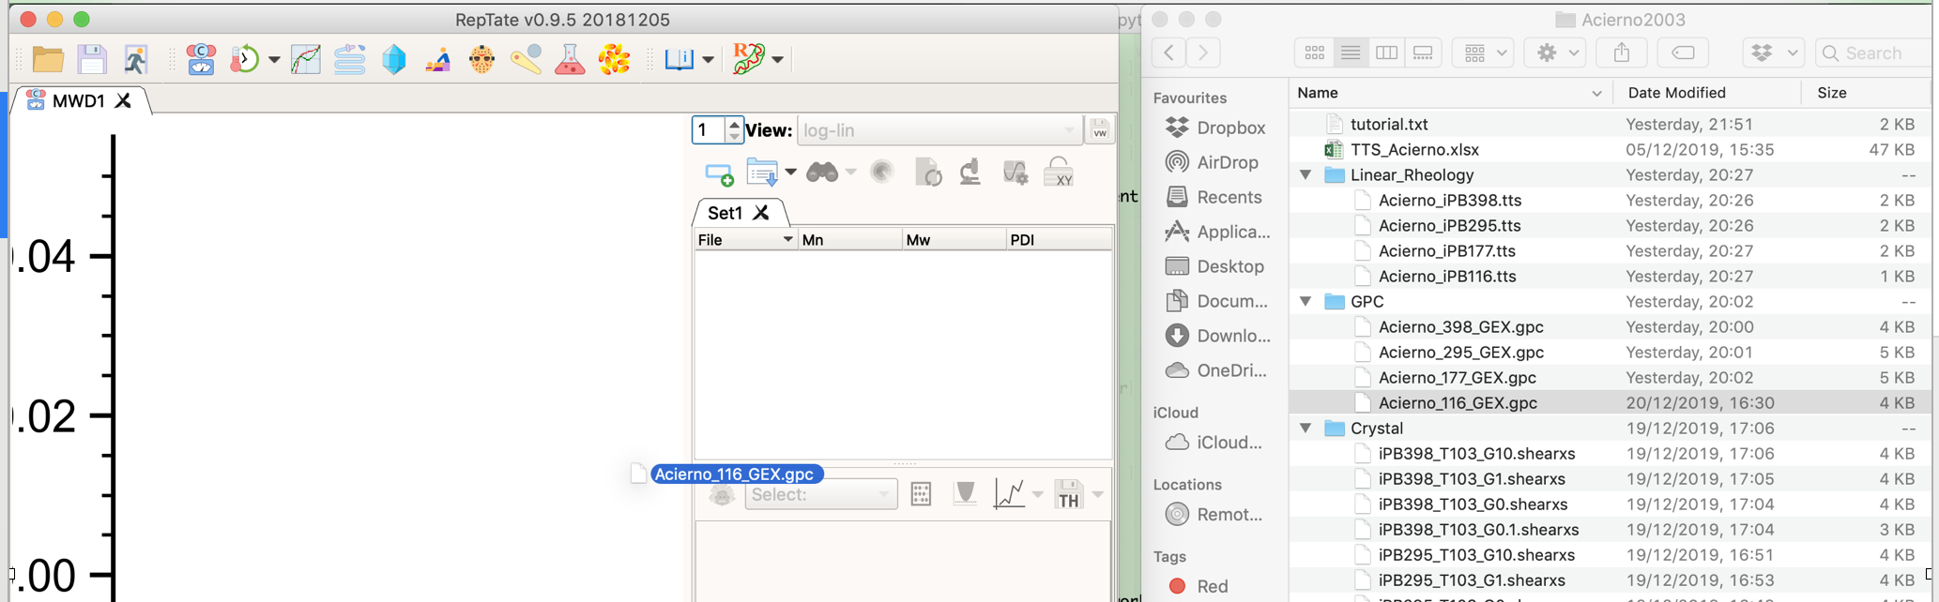
* Load the descritized MWD theory
* Choose 10 bins for the theory

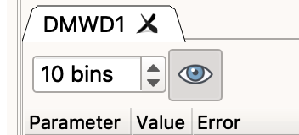

* Double click on ‘DMWD1’ and rename this iPB116

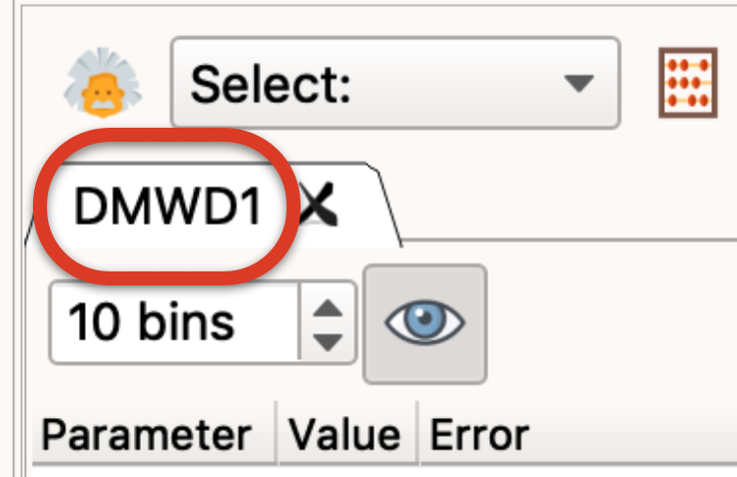

# Check MWD and tube model parameters against linear rheology

* Load the ‘Linear Viscoelasticity’ application (Click on the  icon on the top toolbar)
* From the folder ‘Linear_Rheology’drag and drop the file ‘Acierno116.tts’ on to the Reptate window 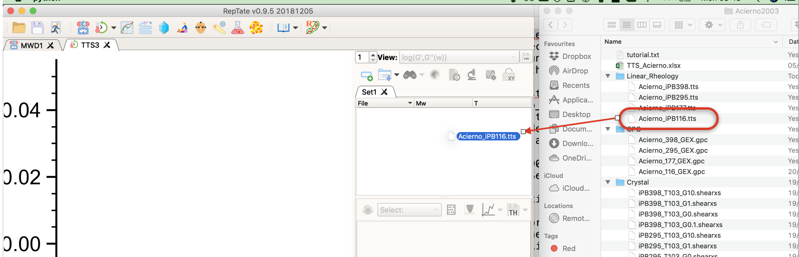
* Load RDP LVE theory (the linear viscoelastic version of the Rolie-Double Poly model)

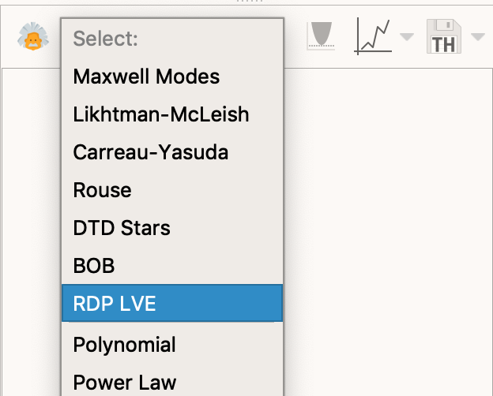

* Click 'Get modes (MWD app)'

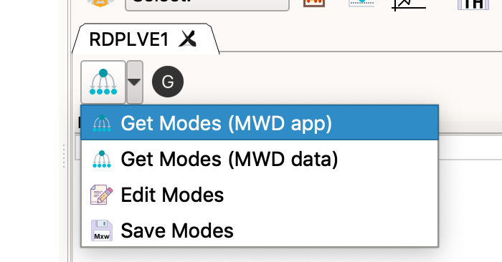

* Set Me=9.5e3; taue=3.90E-06; choose MWD1.Set1.iPB116 from the list of molecular weight distributions; and click OK to exit. *This value of Me for iPB was determined by data from C. Liu et al. [J. Rheol. , 63(1):167-177, (2019)] which included both high and low frequency measurements. The tau_e value is a best fit to the iPB116 measurments in this tutorial.*



* Click the Modulus Correction button and set GN0= 2.60E+05. *This plateau modulus value was determined by the values of Me and the density.*

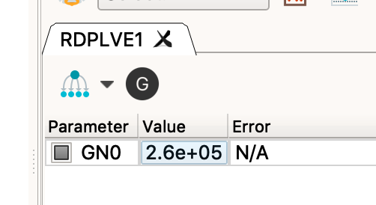

* You should see something like

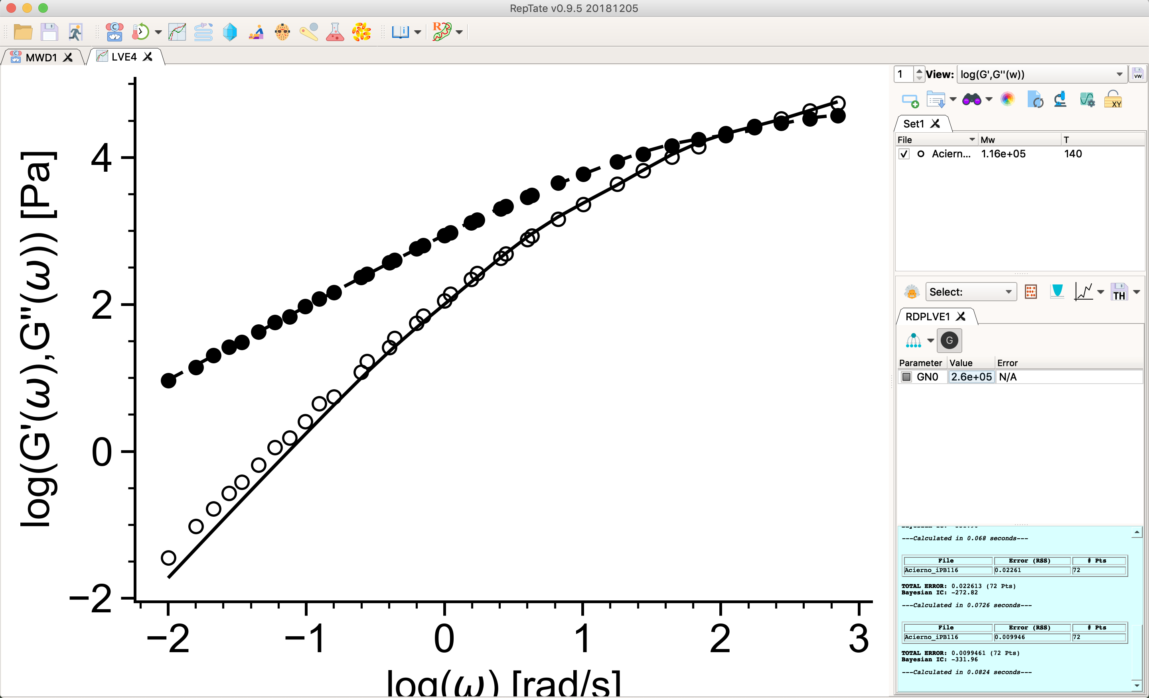

*This confirms that the tube model parameters and molecular weight distribution capture the linear rheology.*

# Load, view and model the crystallisation data

* Load the Crystal application (Click on the crystal application  on the top toolbar)
* From the folder ‘Crystal’ drag and drop the 4 files that begin ‘Acierno116’ and end ‘.shearxs’ on to the Reptate window 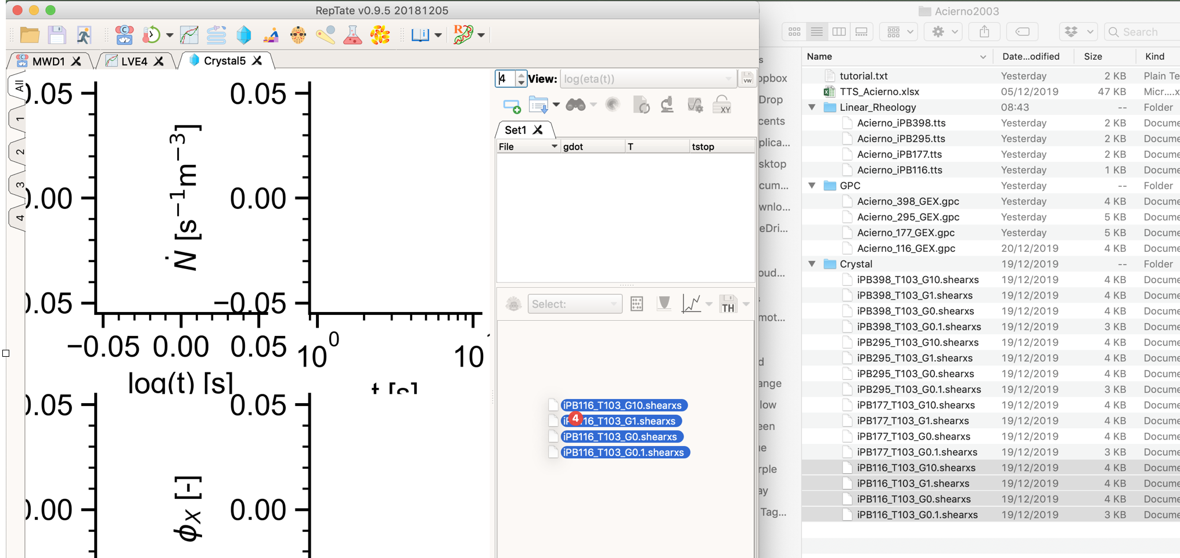
* Select view 1 (on the upper left of the window)

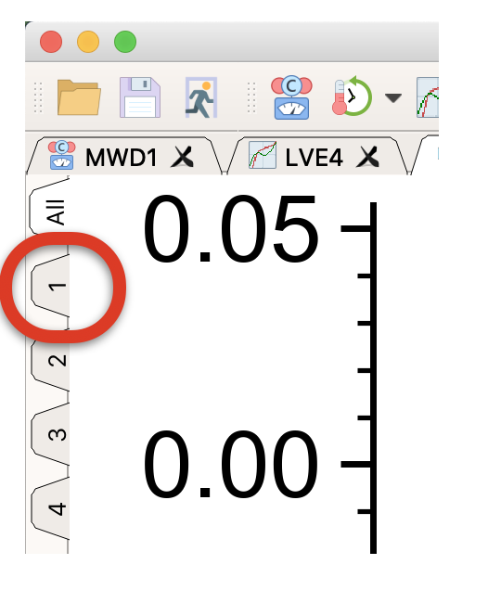

* From the ‘views’ list (upper right of window), select ‘sigma(log(t))'

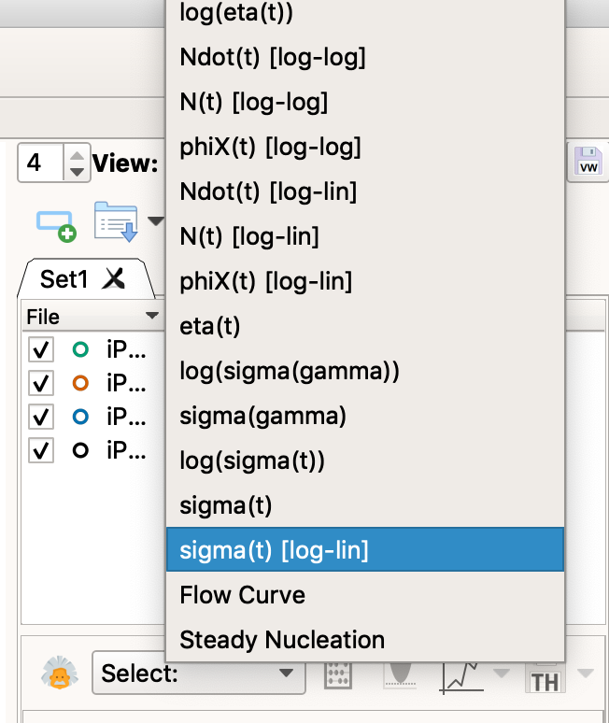

* Go to view 4 (upper left of window) and from the views list select ‘phiX [lin-log]’
* Choose view ‘All’ (upper left of window)
* Load GO-polyStrand model (choose the model from the drop down list and then click the theory icon )

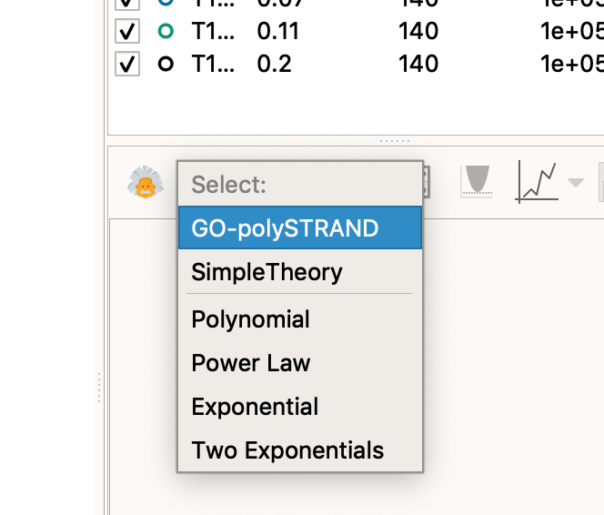

* Click 'Get modes MWD app'

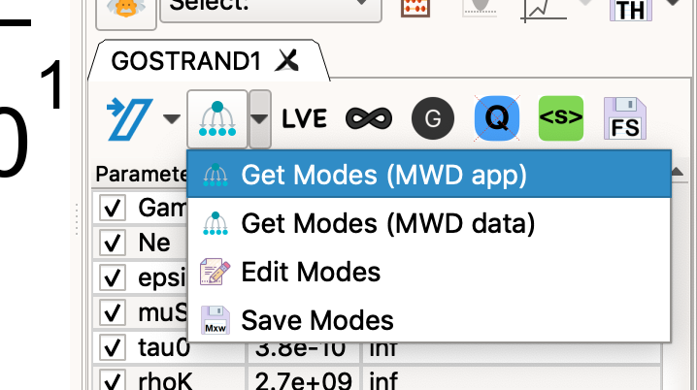

* In the pop-up window set Me=9.5e3; taue=2.340E-05; choose MWD1.Set1.iPB116 from the list of molecular weight distributions; and click OK to exit

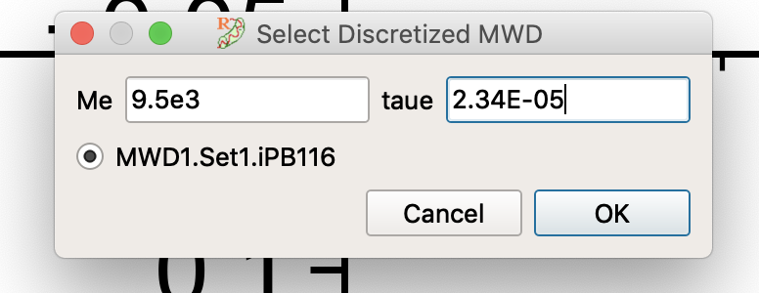

*This is the taue from the linear rheology comparison above, but shifted to the temperature of the crystallisation experiments (140oC -> 103oC).*

* Click the ‘Modulus Correction’  and ‘Ignore Quiescent’  buttons.
* Set the model parameters

Gamma 2

Ne 9

epsilonB -0.002

muS 1.04

tau0 3.12e-07

rhoK 5.3e+08

G_C 0.063

N_0 1.3e-12

GN0 260000

You can enter these by hand or copy these parameters and then choose ‘Paste Parameters’

*The heterogeneous nucleation density, N_0, is obtained from the quiescent crystallisation measurements. The plateau modulus is from above; Ne (Kuhn steps per entanglement), G_C (crystal growth rate) and rhoK (Kuhn step density) are from the literature; and epsilon, muS and tau0 are fitted to these FIC measurements.*

* Click to run the model [This should take about 30 seconds]. You should now see

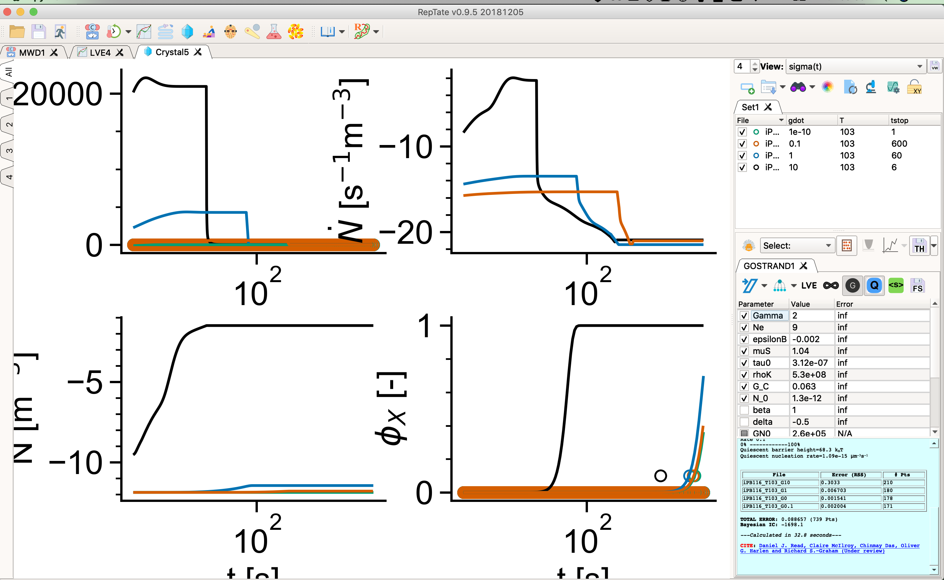

* Close the mode window by clicking 'Ok'

# Focus on the region of the measurements

* Choose view 4 (upper left part of the window)
* Click ‘show/hide’ toolbar’  (top right corner underneath the views selector)
* Click the ‘Edit axis’ button  (lower left region) to bring up the axis properties
* Change the X-Axis: Left value to ‘1e3’
* Click ‘Apply’ or ‘Ok’
* Click ‘Lock XY axis’ icon (top right corner)
* You should see

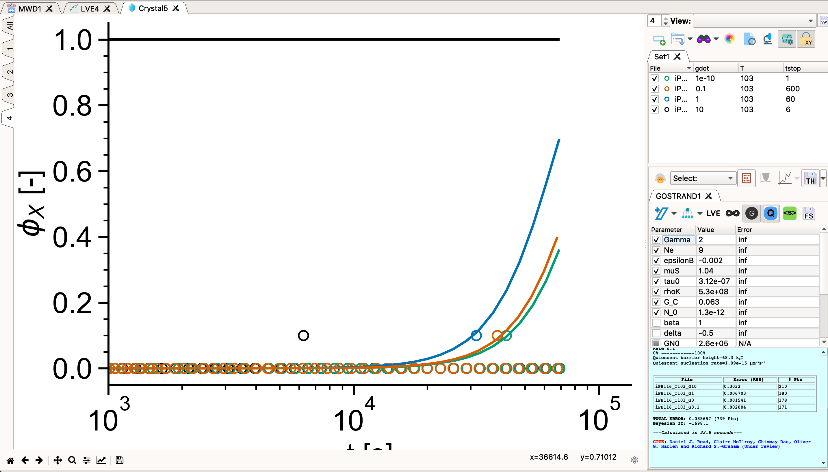

*Note how all but the highest shear rates are captured. Experiments at this highest rate show a rod-like crystal morphology.*

# Model the other molecular weights in the series

* Repeat steps 1-4 for the other 3 molecular weights in the series (iPB177, iPB295 and iPB398).
* Create new MWD, Linear Rheology and Crystal windows for each new molecular weight.
* You’ll find GPC, linear rheology and crystallisation data in the same folders.
* For the FIC measurements you can past the following model parameters for each material
  + Gamma 2
  + Ne 9
  + epsilonB -0.002
  + muS 1.04
  + tau0 3.12e-07
  + rhoK 5.3e+08
  + G_C 0.063
  + GN0 260000

Also use the same Me value (9.5e3).

* All model parameters are the same as above, except for taue and N_0, which can be fit to the linear rheology and quiescent crystallisation measurements, respectively. (I also used slightly different numbers of modes for the discrete molecular weight distributions but this should not affect the results).
* Suggested parameters are:

iPB177

RDP modes:11

Tau_e (140oC): 3.5e-06

Tau_e (103oc): 1.53E-5

N_0: 8.3e-12

iPB295

RDP modes:14

Tau_e (140oC): 3.30E-06

Tau_e (103oc): 1.49E-5

N_0: 12e-12

iPB398

RDP modes:12

Tau_e (140oC): 2.30E-06

Tau_e (103oc): 7.90E-6

N_0: 37e-12

* You should find that the model predicts accurately at the lower shear rates, but overpredicts the crystallisation kinetics for large shear rates, particularly at higher molecular weights.

# Model using the Smooth-polyStrand model

*The smooth-polyStrand accounts for local exhaustion of long chains around the nucleation. This improves the overprediction of the nucleation rate at high Weissenberg numbers. The only new parameters are the nucleus roughness penalty (Kappa0) and the stem search volume (Qs0) and these take the same values as in the Pantani comparison (see previous tutorial).*

For each molecular weight carry out the following steps:

* Copy parameters from the Go-polyStrand model
* Load smooth-Polystrand model
* Paste parameters into this new model
* Click the 'Neglect quiescent' button
* Change the three parameters below:
* Gamma 1.3
* epsilonB 0.1466
* muS 1.1

*These three are the FIC parameters and, again, are the same for all 3 molecular weights. This combination of Kappa0, epsilon and muS gives the same quiescent barrier as in the Go-polyStrand model comparison, above).*

*Summary: we can fit the lowest molecular weight data and then predict the FIC data for the remaining materials, from a knowledge of only the molecular weight distribution, linear rheology and quiescent crystallisation.*

# Things to try

* Change Gamma to adjust the sensitivity to shear.
* Switch on the average stress model.
* Make *small* changes to epsilonB to adjust the shear induced barrier.
* Change the molecular weight distribution by clicking ‘Get modes (MWD data)’ and changing the Molar Mass values (M) by hand. You can also change phi but this needs to add up to 1.
* Return to ‘All’ views and try changing shear time by double clicking on a data step and changing tstop.